Multiple Choice- Please write your answer in the space provided. (2 points each)
____1. Why do doctors suggest that people get a flu vaccine each year?
A Viruses replicate more rapidly over time.
B Viruses can mutate from year to year.
C Vaccines are absorbed by the body after a year.
D Vaccines get stronger over time.
____2. Why is a healthy diet important?
A It maintains a constant body temperature.
B It prevents damage to internal organs.
C It makes oxygen for all the cells in the body.
D It supplies the body’s needs for growth and energy.

____3. Cells perform all the different functions in an organism. Within a cell, _____ is/are the command center of its activity.
A ribosomes B the nucleus C vacuoles D the endoplasmic reticulum

____4. Ten people became sick with the flu after attending a school dance. What is the
scenario that could best explain how the people got sick?
A contact with environmental sources
B contact with an infected animal
C contact with a contaminated object
D contact with an infected person

____5.Which of the following is not true?
A Viruses can only multiply inside a living cell.
B Viruses have genetic material.
C Virus particles are smaller than bacterial cells.
D Diseases caused by viruses can be cured by antibiotics

____6. How is the cell membrane important to the process of osmosis?
A It allows water to move into the cell.
B It allows all materials from the outside environment to move into the cell.
C It traps water and nutrients that would otherwise be unable to move into the cell.
D It collects nutrients from water in the outside environment and moves them into the cell.

____7. A primary characteristic of Euglena is that they contain_________.
A a nucleus B chloroplasts C cytoplasm D mitochondria

____8. Which is true of all living things?
A They produce sugar. B They require oxygen.
C They are composed of cells. D They require carbon dioxide.

____9. Which is a difference between multicellular and unicellular organisms?
A Unicellular organisms are specialized, while multicellular organisms are not.
B Unicellular organisms are differentiated, while multicellular organisms are not.
C Multicellular organisms have more than one cell, while unicellular organisms have only one cell.
D Multicellular organisms have only one cell, while unicellular organisms have more than one cell.

____10. Which organisms are usually multicellular?
A bacteria B eukaryotes C prokaryotes D protists

____11. Which of the following statements is true?
A Plants cannot respire because they have no mitochondria
B Photosynthesis produces energy.
C Animals cannot photosynthesize.
D Only plants photosynthesize and only animals respire.

____12. Which of the following is paired correctly?
A diabetes: virus
B AIDS: protist
C rabies: virus

Use the following data table to answer Questions 13 and 14.
Type of Cancer | Estimated New Cases (2003) | Five Year Survival Rate (1992-1998)
Prostate (males) | 221,000 | 97%
Breast (females) | 211,000 | 86%
Lung | 172,000 | 15%
Colon and rectum | 148,000 | 62%
Bladder | 57,000 | 82%
Melanoma (skin) | 54,000 | 89%

____13. The type of cancer with the best five-year survival rate is
A prostate cancer B bladder cancer
C breast cancer D lung cancer

____14. A reasonable inference that can be made from the data is that
A lung cancer is easy to diagnose and hard to treat
B prostate cancer is hard to diagnose and hard to treat
C very few females survive for five years after being diagnosed with breast cancer
D lung cancer is the most common cancer

____15. Which part is responsible for the movement of the amoeba?
A the nucleus B the pseudopod
C the cell wall D the flagellum

____16. A protist is a _____________ organism.
A one-celled B multicellular
C viral D bacterial

____17. Which of the following cell structures would you expect to be the most involved in photosynthesis?
A cell wall B flagella C chloroplasts D ribosomes

____18. In some one-celled organisms, waste is usually disposed of through_______, thus requiring very little use of energy.
A diffusion
B a sodium-potassium pump
C the endoplasmic reticulum
D the nucleus

____19. Which is the best way to help prevent the flu from spreading
A getting a vaccination
B taking antibiotics
C eating fruits and vegetables
D washing hands often
____20. How would smoking tobacco most likely have a negative impact on the ability of
an individual to succeed at physical activities?
A It interferes with balance and coordination.
B It decreases the ability to make decisions rapidly.
C It decreases stamina and cardiovascular efficiency.
D It decreases the speed and power of muscle contractions.

____21. You are using a microscope that has and eyepiece number of 10X. What would be the total magnification when using an objective of 5X?
A 5X B 15X C 50X D 500X

____22. A primary characteristic of paramecium is the presence of ________.
A chloroplasts
B a mouth structure
C a nucleus
D a cell wall

____23. What is the purpose of a vaccination for a specific disease/virus?
A to cure the disease once you have it
B to prevent the disease from developing
C to decrease the number of helper T cells in the blood
D to decrease antibody formation

____24. The invention of the microscope helped scientists to determine that many diseases are caused by_____.
A social factors B microorganisms
C antibodies D macroorganisms

____25. Which food provides the most energy for the body in the shortest amount of time?
A potato B meat C milk D fruit

____26. Which of the following is NOT a way in which you can be infected with the AIDS virus?
A sexual contact B reusing hypodermic needles
C sitting on a toilet D blood transfusion

____27. ________ is NOT a virus.
A the common cold
B strep throat
C HIV
D Ebola

____28. Which of the following is a mutagen that can cause birth defects or genetic disorders?
A radiation B certain chemicals C drugs D all of the above

____29. A doctor at a hospital has several new patients who show signs of cholera. When questioning them about what they have eaten in the past few days, all mention having shrimp at a local restaurant. What could one determine about cholera from this information?
A If a person eats shrimp, he or she will become infected
B The water at the restaurant is infected with cholera-causing bacteria
C The conditions in the town are unsanitary.
D Cholera can be passed on through infected seafood.

____30. A health researcher is reviewing data on an epidemic of a never-before-seen disease. He notices that people from the same family or workplace tend to all have the disease. Which of the following would be the most likely way the disease is spread?
A Blood transfusions
B Touching objects an infected person had touched
C a genetic mutation
D drinking water from an infected stream

____31. Which of the following is an effect of the use of antibiotics?
A The treatment of certain diseases has become much easier.
B Strains of antibiotic-resistant bacteria have become more common
C Tuberculosis has been brought under control
D All of the above

32. This chart shows the worldwide number of measles cases over twenty years.
Worldwide Cases of Measles
Year | Measles Cases
1980 | 3,800,000
1985 | 2,800,000
1990 | 1,400,000
1995 | 800,000
2000 | 1,000,000

____Which is most likely the cause of the decline in measles cases from 1980 to 1990?
A antibiotics B chemotherapy C quarantines D vaccinations

____33. Which of these is NOT considered to be alive or living?
A bacteria B plant C prokaryote D virus

____34. Euglena and Paramecium are similar in which way?
A Both are types of plants.
B Both have a cell wall to maintain their structure.
C Both have structures that aid them in movement.
D Both must produce their own food in order to live.

Short Answer
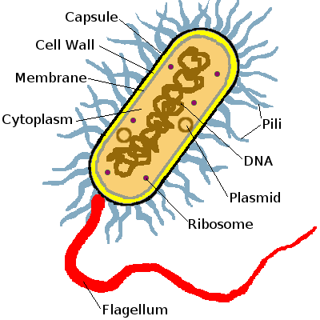
Please identify the following Microbes (5 points each)
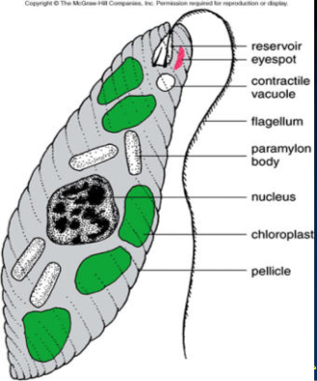
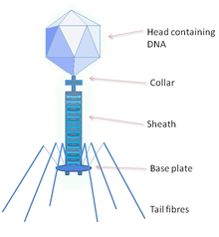
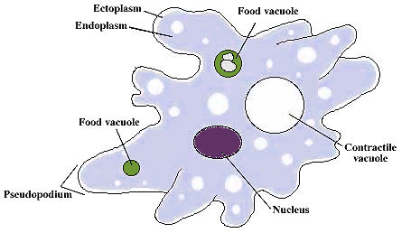
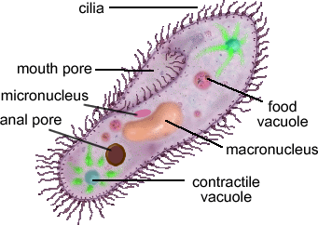

40. What are 2 ways virus and bacteria ARE alike.

BONUS- Can you name all of Santa’s reindeer?

